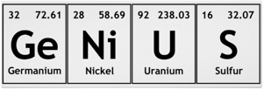

Summer Camp

When: July 17-20, 9am-3pm
Where: Stroud High School
Cost: $5
(Cost includes lunch, t-shirt, & all supplies)
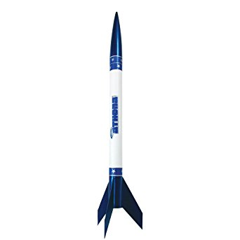
Electricity
Insect collection
Painting
Rockets
Chemistry Experiments

Mad Scientist

Summer Camp

Student Registration

Student Name _____________________________
Parent Name ______________________________
Address ____________________________________________
City ________________ State _____ Zip Code ____________
Phone # _____________________
Grade Entering Fall 2018 ___________

Choose one:
_____ Science (Full Day)
_____ Art (AM only)
Art has the option to do science in the afternoon

